How to Certify Position Description in PeopleAdmin
Supervisor Instructions
Please note: The Position Certification process should be completed for all new employees, when an existing employee changes positions or after there is a major or minor update to an employee’s position description. This process replaces signatures on the paper copy of the position description. If, when verifying the PD, you feel something is incorrect you can contact the person who initiates actions in PeopleAdmin for your Department and they can take the necessary action to update the position.
Step 1 – Login to PeopleAdmin
There are two options
- Login to InsideSOU
- Click on the Online Services Tab
- Click or Recruiting (PeopleAdmin)
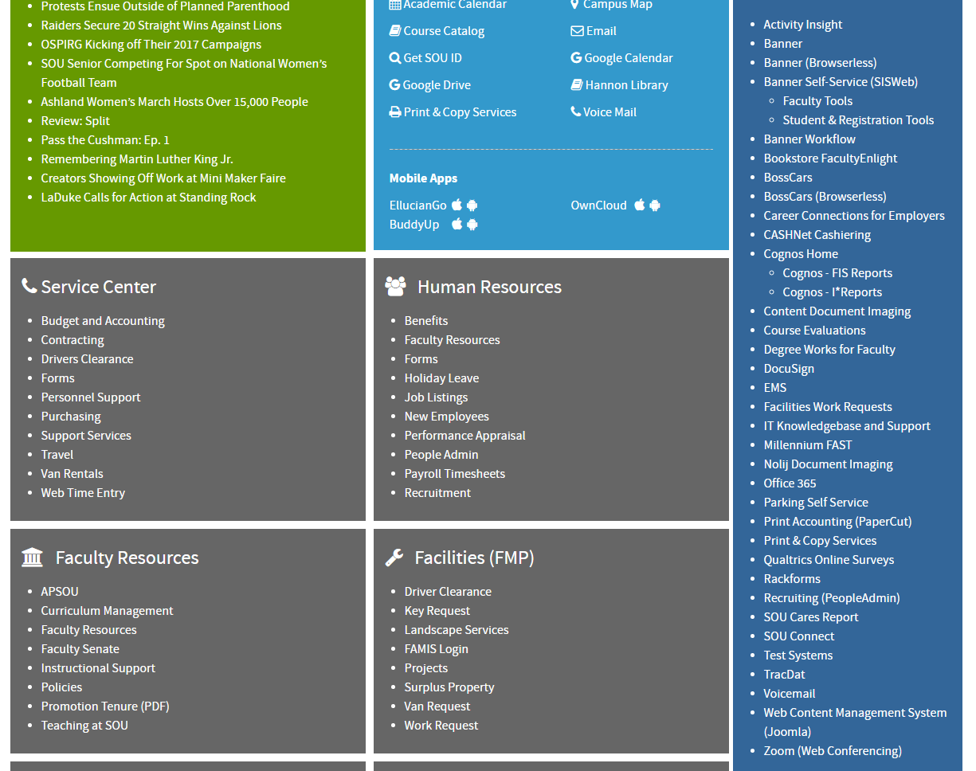

Or

- Go the URL jobs.sou.edu/hr
- Click on the Click HERE to log in with SOU Credentials (Do not try to login on this page).
- Login with your usual SOU credentials. 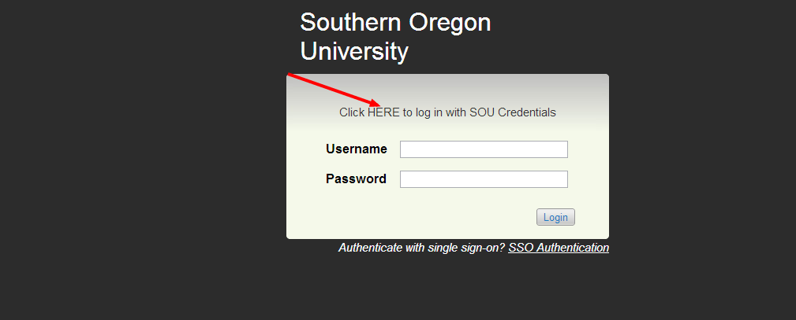
Step 2- Login using your network user name and password

Step 3- When you log in you will see the home screen. You will need to be in the Position Management Screen which will have orange header. If you are not in the position management, hover over the drop down menu to the right of the Watch List tab. And select POSITION MANAGEMENT.
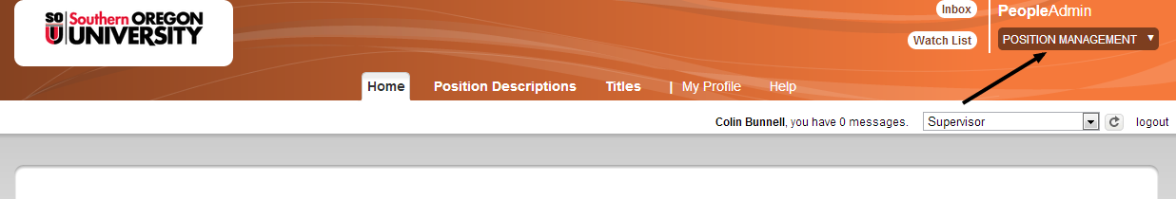

Step 4- Once in the position management screen you will need to select the supervisor view. You will do this in the drop down menu directly under where you selected the position management screen in the white border under the header. You must click the refresh button and look for a green bar to come up across the top of the screen to confirm the view change.
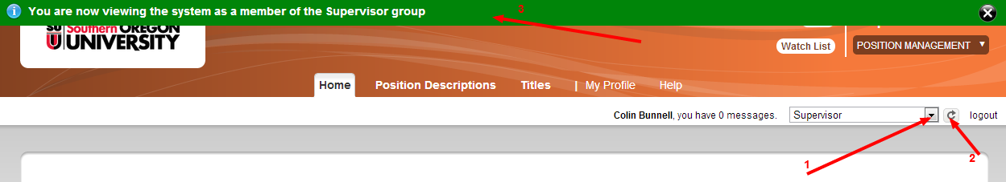

Step 5- Select the tab Position Description and then select the position of the employee you are certifying
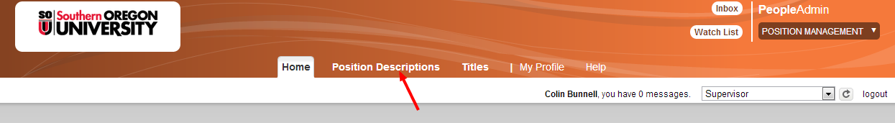
- for this example we will use Classified

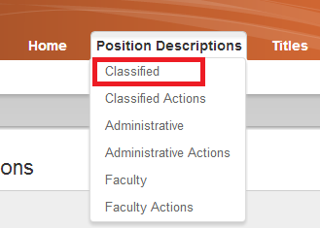
Step 6- Click on More serach options
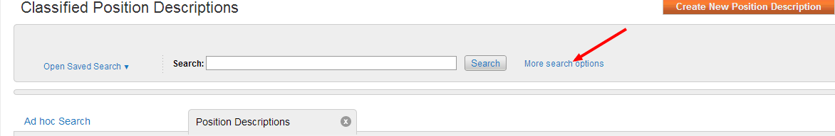
Then type in the employee name. You can use first, last or both. (Note that employees are entered with their legal names)
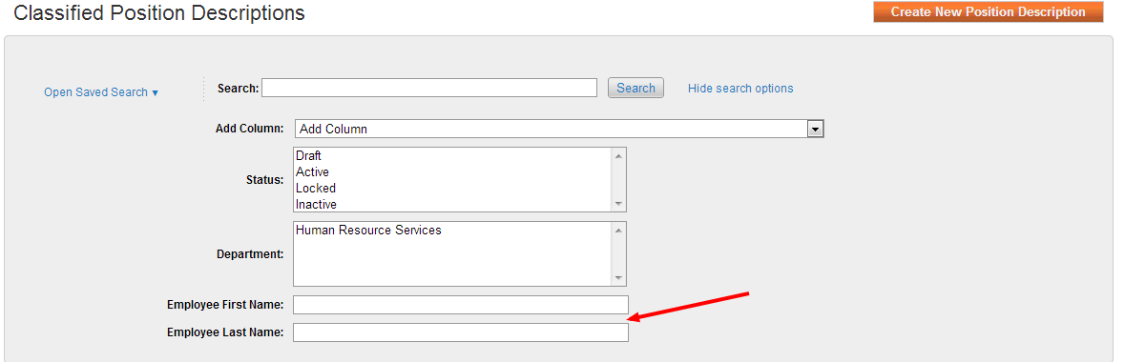

Step 7 Click on the blue job title area (Don not click on the box) and this will direct you to the Position Description summary
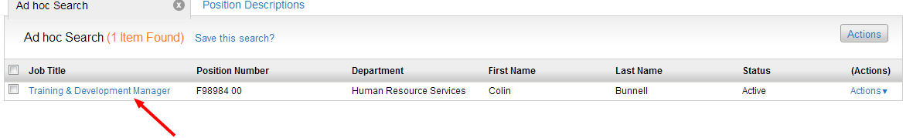
Step 8 Click on Certify PD and when the next page comes up click on the start button
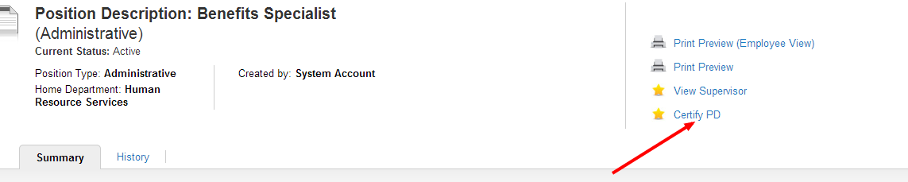
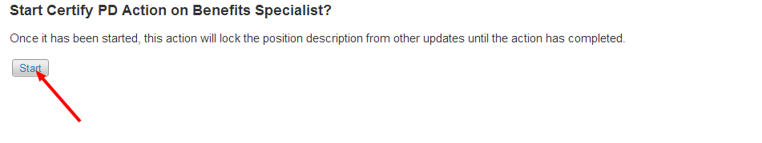
Step 9- In order to ensure that the employee receives an email, please choose the employee’s name from the drop down box underneath the Action Details.

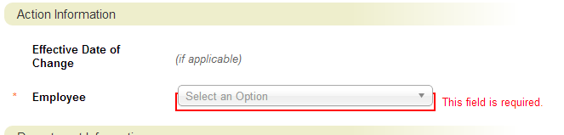

Step 10- Verify the employees Duties, once finished verifying duties, click next.

Step 11- Initial in the box and then click next.
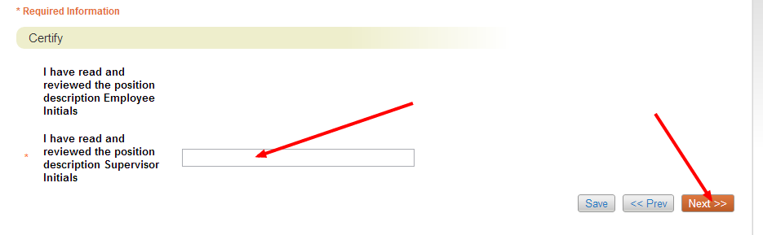
Step 12- Now you are in the summary, click on the Take Action on Action drop down menu and select Employee Review (move to Employee Review) tab.
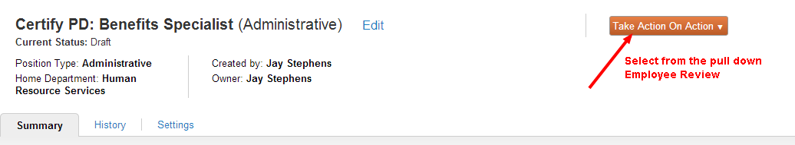

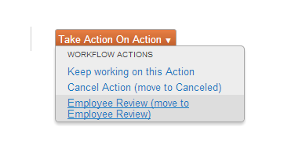
Once you have completed these steps the PeopleAdmin system will send an automated email to our employee and they will then be able to log into the system and complete the certication process.

